**The Adventure**

Programming planning and testing document



Contents

**The Trail** **3**

Overview 3

Flowchart table thing 3

**Testing** **4**

# 

# **The Adventure**

## Overview

Ideas

1. You are an adventurer that is going around looking for the lost village, but can stumble upon a demon that will either kill you or leave you alone depending what choices you make.
2. You are an adventurer but get caught in a bad looking situation where you have to answer questions to get out of it, if you answer the questions correctly.
3. You are a traveller on a quest for the best food, you are asked many questions for you to get to your goal.

## Final choice

What I went with was idea 1 as I thought it would be fun to see what I can create with this kind of game side and as i can implement a good story to this.

## MindMaps

## FlowChart

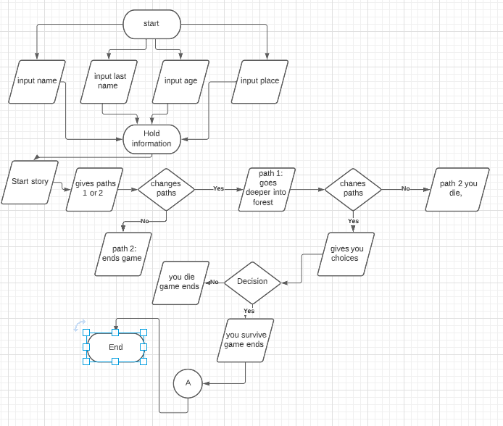

## 

# 

# **Testing**

## Day 1

Brainstorming and mind map:

Today I brainstormed ideas and got a mind map, to show what I am going for.

I only did this today as I had to work on other assignments.

## Day 2

Flowchart:

Today i made the flowchart the best i could to show/explain what i am gonna be doing for my text based game.

I also made the project so I had it set up for when I started coding it.

## Day 3

Start of coding and testing:

Today I started coding the main bits that I needed. I put this onto my usb for backup just in case it corrupted.

I closed it for the morning and went to reopen it in the afternoon but it corrupted my computer and usb so I had to restart my project.

## Day 4

Add more code and test it out:

I only did a bit of code today as I was quite ill and couldn't look at my screen for too long. I added the classes I would be needing, I made sure to have a back up and to make sure it is all organised so things don't get messed up.

## Day 5

Add more code and test it out and research:

I did a bit of research into some adventure games that people have done in the text based way and found some that are very helpful and interesting.

After researching, I got back on with my coding. From the research I did, I was able to figure out how to go about some of the aspects I wanted.

I only did this much today as i was down with covid so i couldn't look at my screen or anything for to long

## 

## Day 6

Add more code and test it out:

i couldn't look at my screen or anything for too long today, so i wasn’t able to get anything done today as i was quite bad with covid this day.

## Day 7

Add more code and test it out:

The coding was going well, but spoke too soon as I got some errors that were only small as I was missing some small bits of code at the end of some lines or I didn't spell things correctly.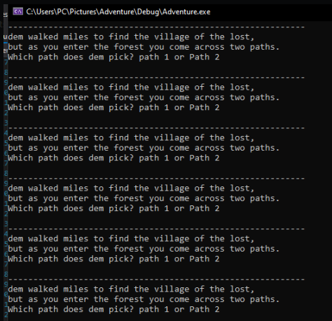

## Day 8

Add more code and test it out:

The problem I had was the code was repeating itself at the level one and not going to the other levels as you can see from the image to the right.

Once I added more of the code I ended up with the two errors that I didn't know how to get rid off. I did manage once but it came back and I couldn't remember how I got rid of it last time. I tried a lot to get rid of this and asked for help and researched them but didn't get really anywhere so I left it as it was annoying me a lot.

## Day 9

Add more code and test it out:

Today I asked for an extension to this assignment due to getting covid and my health i wasn't able to work on it as much as I would have liked.

## Day 10

Add more code and test it out:

I have uploaded my code so far to github but i will be carrying on later as i just need a tiny break away from this code, as it is saying i have two mains when i don't and the other i am not too sure how to go about it.

Add more code and test it out:

After a few hours I got back on with trying to figure out how to solve my errors.

The error I had was that I added the cpp file name up at the top making the error appear as it wasn't needed.

Once that was done my code was looping but realised it was because in the if statements some parts were not correct so it was looping straight after.

Finishing up the code parts making sure it all works.

Once I got all this done I ran through the code again and noticed level three wasn't working like the others.

Then going through and seeing if I have all the things necessary for the assignment.

## Day 11

## Hand in, github.

<https://github.com/DemiM00re/Adventure>

# 

# Reference

www.cplusplus.com. N/A. containers - C++ reference.[online] available at: <http://www.cplusplus.com/reference/stl/>

Stack overflow. N/A. *c++ - std::forward_list and std::forward_list::push_back*. [online] Available at: <https://stackoverflow.com/questions/8742462/stdforward-list-and-stdforward-listpush-back>

Rachel singh. 2020. Let's make a text adventure in C++(part1/2)- open source gamedev. [online] available at: <https://www.youtube.com/watch?v=ajL1KjTch2A>

VertoStudio3D. 2017. Programming an adventure game in c++ ::episode 6:: programming items pt 2. [online] available at: <https://www.youtube.com/watch?v=jcXK2iuMVDg&t=169s>

Luksa Ponik. N/A. C++ text based adventure game. [online] available at: <https://www.youtube.com/watch?v=oqvNEI6Wf2A&t=918s>

MrStormUMA. 2017. Text adventure game. [online] available at: <https://www.youtube.com/watch?v=3foH7ZfC-Hk&t=259s>